: :

**Facebook: Oconomowoc Volleyball Club Organization**

**Twitter:**

**@OVBCWI**

**TRYOUTS :**

**10 – 14 Year olds**

Sunday, Oct. 8 @ Ocon HS

-10’s

11:00-12:30pm

-11’s/12’s

11:30am-1:30pm

-13’s/14’s

8:30am-10:30am

\***Registration online**

**Tryout fee**:

$20 Advance registration

$25 Registration at-the-door

(online registration closes at 8:00pm of Oct. 7th)

**Important Dates:**

**Skills ‘n Drills:**

Oct 3rd 10’s, 11’s, 12’s

Oct 4th 13’s, 14’s

**Only Tryout**

Oct. 8th 10’s-14’s

Oconomowoc VBC is a club committed to growing the love of the game of volleyball. Players will learn all aspects of volleyball and the ability to play multiple positions, so they are equipped to compete for excellence.

**Club Fees:**

10’s : $475

Practice once a week Wed.6:00-7:30pm

(Dec-Apr)

Teams will compete in 6-7 tournaments

11/12’s : $625

Practice twice a week (Dec-Apr)

Teams will compete in 8-9 tournaments

13’s/14’s : $815

Practice twice a week, and additional positional once a month (Dec-Apr)

Teams will compete in 9-10 tournaments and a national qualifier.

*All Practices are held at Silver Lake Intermediate School

**Developmental Program**

This program is designed to help your child develop not only volleyball skills but body awareness and athletic ability. The players will spend time each week learning the individual skills of serving, passing, setting, and quickness to the ball.

We will take a maximum of 12 players so the instructor can have more individual time with the players. One 9-week session will be available on a first come, first serve basis. **Looking to do a boys session and a girls session.**

**Fee for 2-3rd Grade:** $90 fee will include an hour each week for all 9 weeks and a t-shirt for each player

**Fee for 4-5th Grade:** $100 fee will include an hour and a half each week for all 9 weeks and a t-shirt for each player

($10 off when you sign up for both sessions)

**\*\*Registration will open Mid November on our website\*\***

Questions??? Email the Director: Michelle Bruss @ oconomowocvbc@yahoo.com

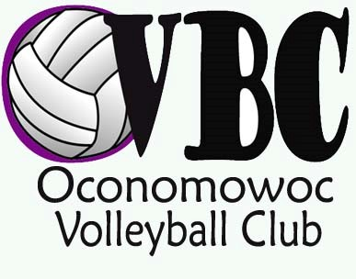

**Visit our Website for online registrations and other Information** www.oconomowocvbc.com